Modelling of …. (Font: 14 Times, Bold, Capitalized each word)

First Lastª, First Last^{b}, First Last^{a,*} (Font: 14 Times)

ªGraduate Faculty of XX, University of XX, City, Country. (Font: 10 Times, italic)
^{b}Department of Energy Xxx Xxx, (EXX), P.O. Box: xxxx, City, Country.
ARTICLE INFO

Article Type:

Received:
Accepted:

Keywords:
Type 3-6 keywords
One keyword per line
One keyword per line
One keyword per line
One keyword per line
One keyword per line

A B S T R A C T
In this paper, quasi-dynamic analysis of a building integrated photovoltaic (BIPV) system has been investigated by using data mining for a simulated case study. To cover the aim of this research, practical generated energy, power conversion efficiency, energy efficiency and exergy efficiency have been analysed as key performance indicators for evaluation of system dynamics. Results of data analytics can be usefully applied to investigate the performance of system in real conditions of operation in compare to the results of models. In this paper, quasi-dynamic analysis of a building integrated photovoltaic (BIPV) system has been investigated by using data mining for a simulated case study. To cover the aim of this research, practical generated energy, power conversion efficiency, energy efficiency and exergy efficiency have been analysed as key performance indicators for evaluation of system dynamics. Results of data analytics can be usefully applied to investigate the performance of system in real conditions of operation in compare to the results of models. In this paper, quasi-dynamic analysis of a building integrated photovoltaic (BIPV) system has been investigated by using data mining for a simulated case study. In this paper, quasi-dynamic analysis of a building integrated photovoltaic (BIPV) system has been investigated. (200 words, 10 Times)

1. Introduction (Font: 10 Times, Bold)
The efficiency of a solar photovoltaic (PV) cell can be considered as the ratio of electricity generated to solar irradiation. In this definition only the electricity generated by a solar PV cell is considered and other properties of PV modules, which might affect efficiency, such as ambient temperature and cell temperature are not directly considered [1]. Building Integrated PV (BIPV) systems play an important role in generating electricity. BIPV’s are defined as PV modules which can be integrated to building envelope by replacing conventional building materials [2]. The performance of such systems can also be evaluated in terms of exergy efficiency [3]. Exergy (sometimes called availability) is defined as the maximum theoretical useful work obtainable from a system as it returns to equilibrium with the environment [4].
Several studies and researches was done to cover the aim of performance evaluation for PV and BIPV systems. Joshi and Tiwari [3] have reviewed energy and exergy efficiencies of a hybrid photovoltaic–thermal air collectors. Dubey et al. [5] have provided analytical expression for electrical efficiency of photovoltaic thermal hybrid air collector in their research. Agrawal and Tiwari [6] have investigated life cycle cost assessment of building integrated photovoltaic thermal systems. In their research, they also analyised system performance using energy and exergy analysis. Mishra and Tiwari [7] have carried out energy and exergy analysis of hybrid photovoltaic thermal water collector for constant collection temperature mode. Hepbasli et al. [8] have done an exergoeconimic assessment of a building integrated photovoltaic system. Shakouri et al. [9] have investigated an energy and exergy optimization for water cooled thermal photovoltaic system using genetics algorithm.
This research goes one step forward in compare to the previous studies. In this study, authors have investigated performance evaluation of a simulated BIPV system using data anlytics and considering energy and exergy quasi-dynamic analysis. Results of this study would be useful for investigation of system dynamics in simulation or operation of the system.
2. Materials and Methods (Font: 10 Times, Bold)
Figure 1 shows the three-dimensional view of the studied BIPV system. The geometry of sections A, C and E provide an application of both glass and PV modules as outer façade. Glass could be used in parallel to glass windows of the existing façade and PV modules could be applied in parallel to connecting small walls between levels. Due to the geometry of sections B and D for the existing façade which is a wall, the proposed outer façade being shaped by integrated PV modules wall. Total available area for PV modules is 60 (m²) and the maximum power output of the designed system is 10.62 (kW). Type of the selected PV modules is mono-crystalline silicon with reference efficiency equal to 14.96 %. Short circuit current and open circuit voltage of the PV modules are 4.8 (Amp) and 21.7 (V), respectively. In order to investigate the behavior of BIPV system to the climate parameters, hourly data for one year starting by 2017-03-01 and ending to 2018-02-28 have been gathered. Irradiance data have been gathered through Solar Radiation Data (SoDa) [10], European Commission – Photovoltaic Geographical Information System [11] and The World Bank – Global Solar Atlas [12]. Gathered data have been processed and it was understood that the BIPV system is available for generating electricity in 2517 hours of the studied year due to the availability of vertical solar irradiance. The most important climate parameters which have been reviewed are including ambient temperature, vertical solar irradiance and wind velocity. In order to evaluate the effect of different climate parameters on the performance of system, practical generated energy and three PV system efficiencies can be considered including power conversion efficiency, energy efficiency and exergy efficiency.
For solar PV cells, efficiency measures the ability to convert radiative energy to electrical energy. The electrical power output is the product of the output voltage and the current out of the PV device, taken from the current–voltage curve (I–V curve). This conversion efficiency is not a constant, even under constant solar irradiation [1].

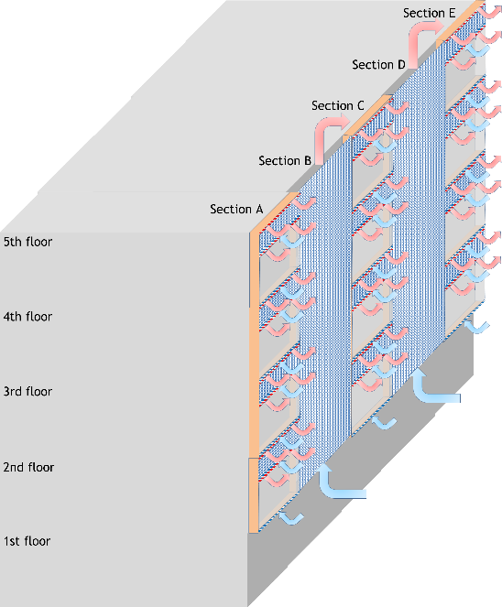
Figure 1. Three dimensional view of the BIPV system (Font: 10 Times)
However, there is a maximum power output point, where the voltage value is V_{m}, which is slightly less than the open-circuit voltage V_{oc}, and the current value is I_{m}, which is slightly less than the short-circuit current I_{sc}. E_{GH} represents the highest energy level of the electron attainable at maximum solar irradiation conditions (E_{GH}= I_{sc}V_{oc}). It is recognized that there should be an active relational curve from I_{sc} to V_{oc}. E_{L} represents the low-energy content of the electron, which is the more practical energy (E_{L}=I_{m}V_{m}). The maximum power point is restricted by a ‘fill factor’ FF, which is the maximum power conversion efficiency of the PV device and is expressible as [1]:

(1)
The enthalpy of a PV cell with respect to the reference environment, ΔH, can be expressed as [1]:

(2)
where C_{p} denotes the heat capacity, T_{amb} the ambient temperature and T_{cell} the cell temperature.
3. Results and Discussion (Font: 10 Times, Bold)
Table 1 shows the results of regression models based on data analytics. According to the results of data analytics and based on the statistical analysis test results including R-square and t-statistical, both vertical solar irradiance and cell temperature have significant variation on the extracted mathematical correlations for key performance indicators pf BIPV system.

Table 1. Results of the statistical analysis based on data analytics and regression models (Font: 10 Times)
Key performance indicator | R-square | t-stat  G_{tV} | t-stat  T_{cell}
Energy generation | 0.9983 | 298.6 | -60.6
Power conversion efficiency | 0.8291 | 32.7 | -13.7
Energy efficiency | 0.9475 | 56.6 | -19.6
Exergy efficiency | 0.8611 | 36.1 | -14.5

Figure 4 illustrates a comparison on theoretical and practical simulated energy generation during one-year application of the system. It is obvious that practical simulated energy generation is lower than theoretical amounts due to differences between reference efficiency and energy efficiency of the PV module cells.
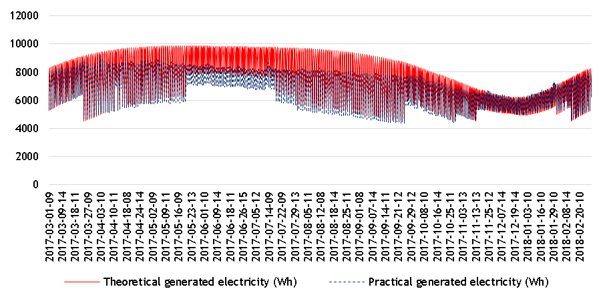
Figure 4. Calculated theoretical and practical energy generation of BIPV modules in quasi-dynamic conditions

4. Conclusions (Font: 10 Times, Bold)
In this research, quasi-dynamic analysis of a building integrated photovoltaic (BIPV) system has been investigated by using data mining for a simulated case study. Practical generated energy, power conversion efficiency, energy efficiency and exergy efficiency have been analyzed as key performance indicators for evaluation of system dynamics. Results of data analytics shows that performance of the BIPV system is highly dependent on changes in cell temperature and solar vertical irradiance. In conclusion, developed regression models for all key performance indicators illustrates a significant result for statistical tests including R-square and t-statistical. Therefore, obtained mathematical functions according to the data analytics in quasi-dynamic modes can be usefully applied to investigate the performance of system in real conditions of operation in compare to the results of models.

Acknowledgements (Font: 10 Times, Bold)

This research was supported by Iranian Fuel Conservation Company (IFCO). Authors appreciate colleagues of researh and development as well as energy optimization in building departments who provided insight and expertise that assisted the research.

Nomenclature (Font: 9,s Times)
C_{p} | Heat capacity (kJ/K)
E_{GH} | Generated electricity at the highest energy content of the electron (kWh)
E_{L} | Practical generated electricity (kWh)
Ex_{physical} | Physical exergy for PV cell (kJ)
Ex_{solar} | Exergy of solar irradiance (kJ)
Ex_{total} | Total exergy of PV cell (kJ)
FF | Fill factor
G_{tV} | Solar total radiation on vertical surface (W/m²)
I_{m} | Maximum power output point current (Amp)
I_{sc} | Short-circuit current (Amp)
Q_{loss} | Heat losses from PV cell (kJ)
STC | Standard test condition
T_{amb} | Ambient temperature (°C or K)
T_{cell} | PV cell temperature (°C or K)
T_{sun} | Sun temperature (°C or K)
V_{m} | Maximum power output point voltage (V)
V_{oc} | Open-circuit voltage (V)
∆H | Enthalpy of PV cell (kJ)
∆S | Total entropy of system (kJ/K)
∆S_{surround} | Entropy of surround (kJ/K)
∆S_{system} | Entropy of system (kJ/K)
η | Energy efficiency (%)
η_{pce} | Power conversion efficiency (%)
η_{ref} | Efficiency of PV cell at standard test condition (%)
Ψ | Exergy efficiency (%)

References (By EndNote software in Numbered Style)
[1] Dincer, I. and Rosen, M.A. (2007). Exergy, Energy, Environment and Sustainable Development. (ELSEVIER)
[2] Bloem, J.J., Lodi, C., Cipriano, J. and Chemisana, D. (2012). An outdoor Test Reference Environment for double skin applications of Building Integrated PhotoVoltaic Systems. Energy and Buildings, 50, 63-73.
[3] Joshi, A.S. and Tiwari, A. (2007). Energy and exergy efficiencies of a hybrid photovoltaic–thermal (PV/T) air collector. Renewable Energy, 32, 2223–2241.
[4] Coventry, S.J. and Lovegrove, K. (2003). Development of an approach to compare the ‘value’ of electrical and thermal output from a domestic PV/thermal system. Solar Energy, 75(1), 63–72.
[5] Dubey, S., Sandhu, G.S. and Tiwari, G.N. (2009). Analytical expression for electrical efficiency of PV/T hybrid air collector. Applied Energy, 86, 697–705.
[6] Agrawal, B. and Tiwari., G.N. (2010). Life cycle cost assessment of building integrated photovoltaic thermal (BIPVT) systems. Energy and Buildings, 42, 1472–1481.
[7] Mishra, R.K. and Tiwari, G.N. (2013). Energy and exergy analysis of hybrid photovoltaic thermal water collector for constant collection temperature mode. Solar Energy, 90, 58–67.
[8] Hepbasli. A., Biyik. E., Araz. M., Yao. R., Shahrestani. M., Essah. E., Shao. L., Oliveira. A.C., Cano, T.D., Rico. E. and Lechon. J.L. (2016, November). Exergoeconimic assessment of a building integrated photovoltaic (BIPV) system. (The International Conference of SDB16, Chongqing, China)
[9] Shakouri. M., Golzari. S. and Zamen. M. (2016). Energy and Exergy Optimization of Water Cooled Thermal Photovoltaic (PV/T) System Using Genetics Algorithm. Journal of Solar Energy Research, 1(1), 45-51.
[10] http://www.soda-is.com
[11] http://www.solargis.info
[12] The World Bank – Global Solar Atlas

